
Welcome to Safe Food Training monthly newsletter. As the title indicates this newsletter will stimulate thought and discuss issues related to food safety in Minnesota. We will also provide up to date company information about Safe Food Training based in Maple Grove, MN
- Tim Niles, Trainer and Editor-in-Chief.
Upcoming Courses

Course Dates | Locations  (click on location to see map) | Register Now!
Aug 05 Tuesday | Bloomington - LaQuinta Inn (West) | Register Now
Aug 14 Thursday | Burnsville - Best Western Premier | Register Now
Aug 18 Monday | Minneapolis - Aloft Hotel | Register Now
Aug 19 Tuesday | Plymouth - Comfort Inn | Register Now
Aug 21 Thursday | Chanhassen - AmericInn | Register Now
Aug 26 Tuesday | Elk River/ Otsego - Holiday Inn | Register Now
Aug 27 Wednesday | Woodbury - Country Inn | Register Now
Sept 04 Thursday | Bloomington - LaQuinta Inn (West) | Register Now
Sept 09 Tuesday | St Cloud - Holiday Inn | Register Now
Sept 10 Wednesday | Burnsville - Best Western Premier | Register Now
Sept 15 Monday | Plymouth - Comfort Inn | Register Now
Sept 16 Tuesday | Minneapolis - Aloft Hotel | Register Now
Sept 22 Monday | Mankato- City Center Hotel | Register Now
Sept 23 Tuesday | St. Paul - Best Western Kelly Inn | Register Now
Sept 29 Monday | Woodbury - Country Inn | Register Now
Sept 30 Tuesday | Mounds View - Mermaid Event Center | Register Now

Why people choose Safe Food Training:

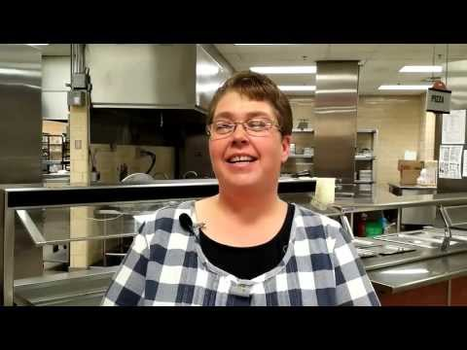
by Colleen Fairbanks
Colleen Fairbanks, Lead Food Services Specialist, Osseo Area Schools, "we had Safe Food Training come in and do our training because they were able to come to us and tailor the training to what our managers needed in order to get their MN food managers license. I would recommend anyone use Safe Food Training because they will tailor the training to what you specifically need in your department.

arloony
Exceptional! Instructor made learning fun!
Deborah Prash
The class was very well done! The interaction with those attending and the visuals used made for an interesting class for all. I will be sending several of my staff to this class for their certification this summer!

